Said:
This is NOT EVEN CLOSE To what is required for the Week 4 draft and the Week 7 final submittal.
- You crammed this work yesterday, the last day of the week.
- You ignored my specific direction and did not use the target market data I gave you to identify the target market in Uptown and surrounding zip codes.
- You critique Velofix’s current operations….WHICH IS NOT THE ASSIGNMENT.
- Your draft looks nothing like the IMC example available to you for the last 26 days in Announcement #2.
- You texted me last night that you were in fact following the IMC example….yet this work does not show that.

It doesn’t seem like you are giving any legitimate effort in this class.
I cannot award a passing grade for this work…
You have a LOT of work to do to fix this for the Week 7 final paper. It needs to look like the IMC example in Announcement #2. CAN YOU DO THIS?

Professor Jeff

Velofix Marketing Communications Plan in Chicago Northside

MATG: Marketing Management
School: Keller Graduate School Of Management
Prof: Jeffrey Oloier
student: Said AL-Mubaidin
09-27-2020

Executive Summary
Velofix Mobile Bike Shop Marketing Communications Plan in Chicago Northside
The founders of Velofix Bik Shop are Boris Martin, Chris Guillemet, and Davide Xausa. The three launched their business idea in 2013 sourced from an innate passion for cycling. The business model that sts the company apart from competition is its structure which allows convenience in repairs at locations chosen by the clients. As a mobile workshop, clients only book the services of the company’s agents online. They can then choose their preferred location and services required.

IMC Objectives
Integrating Marking Communication (IMC) describes the creation of seamless customer experience from integrating various communication brands. Velofix franchisee in North Shore Chicago is under the charge of Phil Sandler as the operator. The IMC goals for Velofix include development of brand awareness, enhancement of purchase options, encouraging repeat purchases among others. The services of the brand range from 3 levels of tune-ups to a la carte services. All of which the customers enjoys from a preferred location. Velofix benefited from free media coverage after their pitch on Dragon’s Den earned them investments worth $300,000.

No….your IMC goals are:
- Establish Velofix as the preferred cycle repair option in the Uptown and neighboring Chicago neighborhoods using a set of specific IMC Action Tools.
- Increase Velofix revenue by 40% by the end of 2021

Market Analysis

SWOT Matrix
Strengths;
- First company with a cloud-based back-end system
- Offers convenience and uniqueness in offering their services to clients
- Passionate and knowledgeable founders
Weaknesses
- No presence in social media channels
- Lack of marketing campaign
- No standard brand message in their communications
Opportunities
- Gradual and sustained growth in cycling with reduced presence of bike shops
- Norway , UK, and the UAE constantly inquire to the business, representing an untouched market
Weaknesses
- High potential of Dragon Den’s publicity to diminish
- The model of industry has low barrier to entry

Assessing the industry using Porters 5 Forces, the threat of new entrants is high. The most significant contributor to this is low start up cost to start a franchise as compared to traditional bike shops. The franchise model also operates as a franchise with several buyers. Such a statistic influences the low rating for bargaining power of buyers. The threat of substitute is medium. Clients have the option of opting for traditional bike shops. The bargaining power of competitors is low. The company structure eliminates the need for multiple suppliers, leading to the organization doing most of their work. The industry has very low competition. Velofix has no competitor in the industry whose structure and mod of operation qualifies as a true mobile bike shop. Not related to the IMC goals

Where is the TARGET MARKET data that I GAVE TO YOU? See below
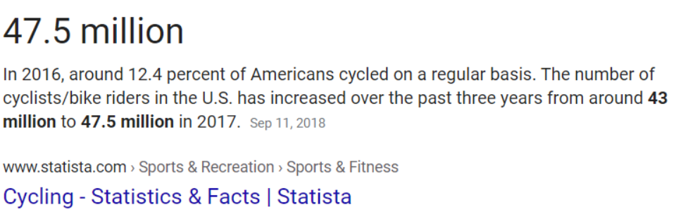
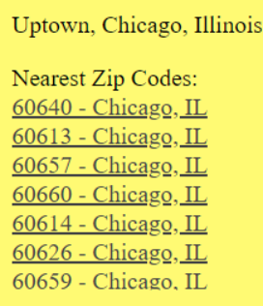
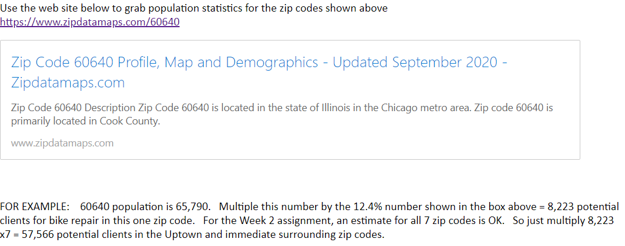

Communications Strategy Plans
The primary target audience for Velofix Mobile Bike Shop is cyclers for the sale or repair of their bicycles. The company structure also target gyms since the institutions have several bicycles for training. The structure of the organization in its outreach to its target audience is not comprehensive, with the company not engaging in various modes of communication

Traditional Media
There is no attempt by Velofix Mobile Bike Shop to exhaust traditional media in increasing its client base. However, the company does benefit from word of mouth marketing owing to good reviews of the services, and new innovative approach to the business model.

Internet SAID…I do not care what Velofix is actually doing….YOUR assignment is to build out a plan to use Social Media, Advertising, Sales Promotion, Direct marketing to drive BUZZ for Velofix in your target areas.
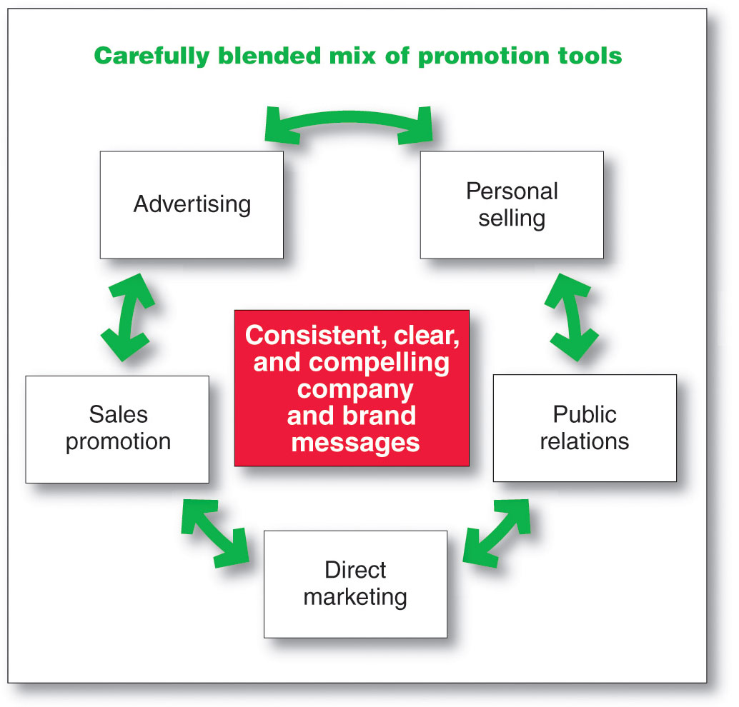

The growth of inexpensive advertising through the internet has done little to motivate any action from Velofix. Their main use of social media channels is only YouTube. The entire franchise has several videos detailing their service range and promotes brand color and emblem recognition. The franchise in Chicago north side has no coverage in social media. Their website misses comprehensive information about the business structure and strategy to reach out to clients. However, an agreement with ‘JY Design & Co’ resulted in revitalization of their website. The deal included wireframes, prototypes, style development, and their integration into brand recognition. The company has not adopted SEO strategies or online advertising forums. Velofix has not yet exhausted direct marketing and sales promotion strategies to improve their communications plan.

Public Relations
The company has not made any identifiable initiatives towards consolidating or launching a public relations strategy. Their website makes no mention of any initiatives towards community or employee relations. There are a few articles on significant third party and investor engaged in the project, but neither makes a mention of strategies to maintain relationships.

Communications Schedule
Velofix have no timeline or calendar that specifies any structure or plan to indicate that the company has any IMC communications schedule.

Budget and Evaluation
The organizational budget for the current year amounts to $150,000. 50% of the share has the objective of building customer relations. As a new direction for the company, the plan involves allowing for and providing timely response to customers, and ensuring that they maintain their relationship. The strategies highlighted as most influential include adverts on social media, and increasing their virtual presence on the same platforms. $7,500 of the total amount is set aside for market research. 45% of the total is also a new approach for the firm, with the funds set aside for promotions.

Conclusions
Velofix lacks sound strategizing and implementation of IMC plan. Their profitability and awareness by consumers is from their first investor on Dragon’s Den. However, the company needs new priorities and strategies to engage the consumer market, and also grow their brand. Their currants budget allocation illustrates recognition of the same concept by the firm.

References
Ciston PR Newswire, (2019, May 20). Velofix Announces Growth Financing from MacKinnon, Bennett & Company. Retrieved from Ciston PR Newswire, (2020, September 26). https://www.prnewswire.com/news-releases/velofix-announces-growth-financing-from-mackinnon-bennett--company-300852793.html
Cunningham, P. (2016, February 13). Velofix – Save Time. Ride More. Vanier College BDC Case Challenge (2020, September 26). http://www.vaniercollege.qc.ca/business-administration/files/2017/06/saturday-VELOFIX-en.pdf
JY Design & Co. (n.d.) Velofix. (2020, September 26). https://jydesign.co/velofix-website/
Rosenbaum, S. (2017). Velofix Mobile Bike Shops. Retrieved from; Road Bik Rider, (2020, September 26). https://www.roadbikerider.com/velofix-mobile-bike-shops-d3/
SGB Media, (2019, October 15). Velofix Continues Momentum with Investment in Strategic Hires and New US Headquarters. (2020, September 26). https://sgbonline.com/pressrelease/velofix-continues-momentum-with-investment-in-strategic-hires-and-new-u-s-headquarters/
Velofix, (n.d.) What we Do: Why Velofix. (2020, September 26). https://www.velofix.com/what-we-do/

